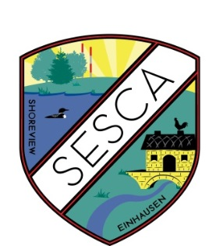
Organization Team:
Bill Kiehnbaum, Director
Cheryl Wason, Director
Roger Hintze, Director
Patty Raeker, Director
Dean Raeker, Director
Larry Rolison, Director
JoAnn Goiffon, Director
Jen Leach, Media Expert

Shoreview-Einhausen
Sister City Association
www.sesca.org

2026 Membership Drive:

Our membership drive for the Shoreview-Einhausen Sister City Association is underway. Please join in making SESCA a success; we appreciate your support! Your contributions and participation help better international understanding and peace. As an all-volunteer organization, our mission is to promote friendship and international goodwill by creating opportunities for all citizens of the greater Shoreview area to experience the German culture.

SESCA is a tax-exempt association and a modest member dues fee from people like you is especially important in maintaining our tax-exempt status. SESCA has been busy in 2025 continuing to promote friendship and international goodwill with German culture experiences.
It is Back! After a long hiatus, a German dinner and program is planned for the Bavarian Hunter Gasthaus in Stillwater. More information is coming soon.
Other recent and future activities include:
- German art at the Minneapolis Institute of Art.
- Informal gatherings at German events around the metro area such as the Bavarian Hunter and Waldmann Brewery.
- Newsletters containing interviews of Einhausen, local personalities and aspects of German culture.
- The German political climate.
Check our web site for information on current activities: www.sesca.org. And follow us on Facebook at https://www.facebook.com/ShoreviewEinhausen. We welcome your ideas for activities in 2026.
You may send a check or pay by credit card. Here are the membership choices:
Membership Types: ___ Family $35 ___ Individual $25 ___ Young Adult $15
We would appreciate receiving your 2026 membership by February 28, 2026. To pay via credit card go to our web site www.sesca.org. Or fill out the form below and send a check payable to “SESCA” to our Treasurer.
Name(s):___________________________________________________________________________________
Street Address:______________________________________________________________________________
City:____________________________State:______________Zip:____________________________________
Mail to: Roger Hintze, Treasurer
Shoreview Einhausen Sister City Assn.
755 Cottage Place
Shoreview, MN 55126-3817

